**Virtual Internship : Salesforce Administrator**

**Salesforce Guided Project**

**Creation of An Application For School Management**

**Submitted by:**

***Anurag Raghunandan Arvelliwar***

***Under***

 

**Creation Of An Application For School Management**

**Project Description:**

The School Management System using Salesforce is a project that involves developing a customized solution for managing various aspects of a school's operations using the Salesforce platform. It includes features such as student information management, attendance tracking, grade management, scheduling, and reporting, all integrated within the Salesforce CRM. This system can be used by schools to streamline their administrative processes, improve communication between staff and students, and enhance the overall learning experience for students.

**Introduction:**

What Is Salesforce?

Salesforce is your customer success platform, designed to help you sell, service, market, analyze, and connect with your customers. Salesforce has everything you need to run your business from anywhere. Using standard products and features, you can manage relationships with prospects and customers, collaborate and engage with employees and partners, and store your data securely in the cloud.

### Creating Developer Org:

Created a developer org named : *App for school management*

User Name : [anuragycce@ycce.in](mailto:anuragycce@ycce.in)

Trail head url : <https://trailblazer.me/id/aarvelliwar>

### Salesforce Object:

Salesforce objects are **database tables that permit you to store data that is specific to an organization.**

Salesforce objects are of two types: Standard Objects: Standard objects are the kind of objects that are provided by salesforce.com such as users, contracts, reports, dashboards, etc.

Salesforce objects are of two types:

* **Standard Objects**: Standard objects are the kind of objects that are provided by salesforce.com such as users, contracts, reports, dashboards, etc.
* **Custom Objects**: Custom objects are those objects that are created by users. They supply information that is unique and essential to their organization. They are the heart of any application and provide a structure for sharing data.

### Creation Of School Object Creation Of Objects For School Management:

For this school management we need to create 3 objects School, Parents and Student.The below steps will assist you in creating those objects.

Creation School object :

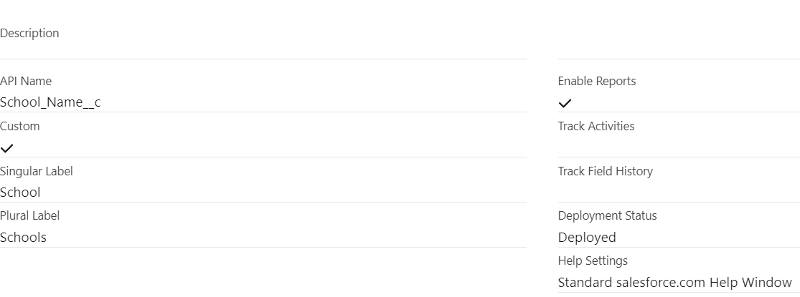

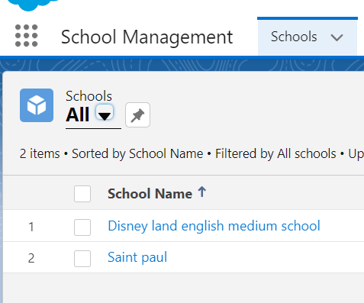

Creation of Student object :

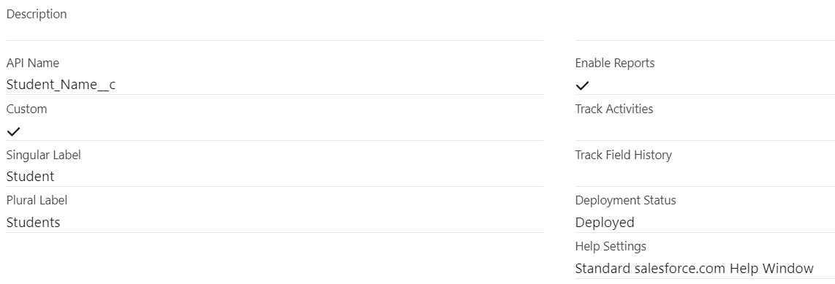

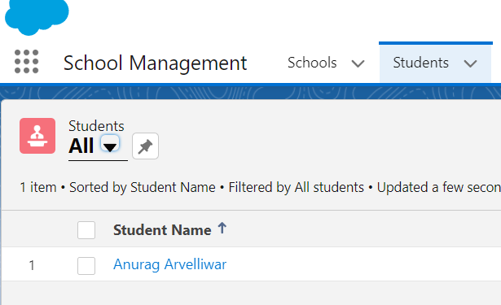

Creation of Parents Object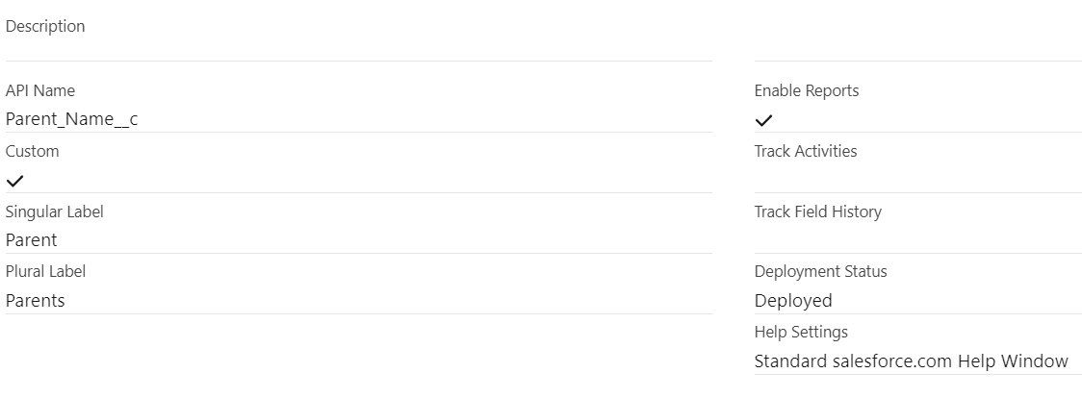

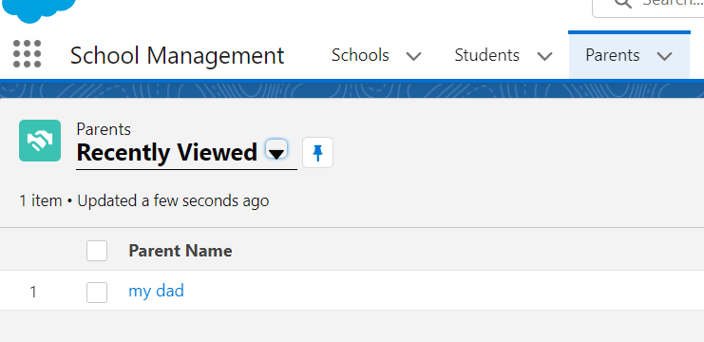

### Lightning App:

Apps in Salesforce are a group of tabs that help the application function by working together as a unit. It has a name, a logo, and a particular set of tabs. The simplest app usually has just two tabs.

There are two types of app –

* + **Standard App**: Standard apps come with every occurrence of Salesforce as default. Many features like Sales, Marketing, Community, call center, content, Salesforce Chatter, App Launcher, etc are present in it.

**Note: The description, Logo, and Label of standard app cannot be altered.**

* + **Custom Apps:** Custom apps are created according to need of user. Custom Apps are made by using standard and custom tabs together

**Note: Logos for Custom Apps can be changed**

### Create The School Management App:

### 

### 

### Fields And Relationships:

An object relationship in Salesforce is a two-way association between two objects. Relationships are created by creating custom relationship fields on an object. This is done so that when users view records, they can also see and access related data.

### Creation Of Fields For The School Objects:

### 

### Creation Of Fields For The Student Objects:

### 

### Creation Of Fields For The Parent Objects:

### 

### Profile:

A profile is a group/collection of settings and permissions that define what a user can do in salesforce.

A profile controls “Object permissions, Field permissions, User permissions, Tab settings, App settings, Apex class access, Visualforce page access, Page layouts, Record Types, Login hours & Login IP ranges.

### Creation On Profile:

### 

### Custom Object Permissions for profile:

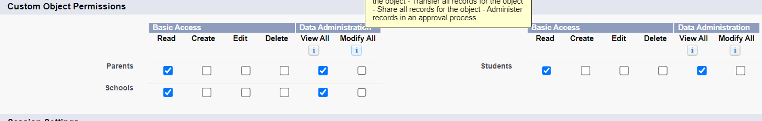

### Users:

A user is anyone who logs in to Salesforce. Users are employees at your company, such as sales reps, managers, and IT specialists, who need access to the company's records. Every user in Salesforce has a user account.

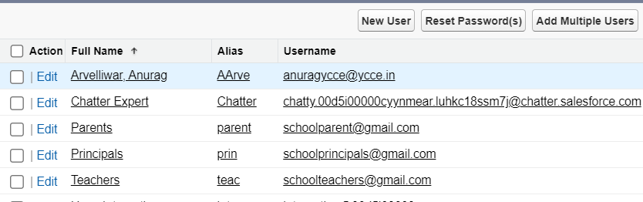

### Permission Sets

A permission set is a collection of settings and permissions that give users access to various tools and functions. Permission sets extend users' functional access without changing their profiles.

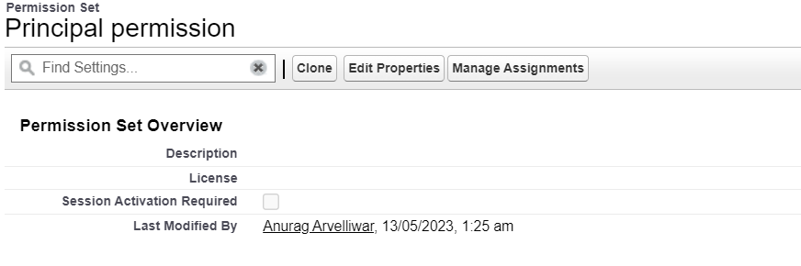

### User Adoption

### Create,view and Deletion of Record (School)

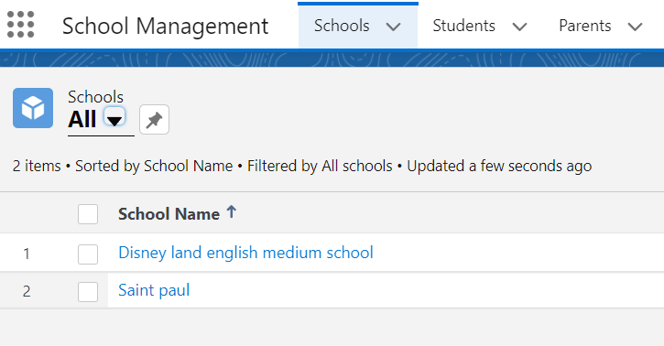

### Reports:

Reports in Salesforce is a list of records that meet a particular criterion which gives an answer to a particular question. These records are displayed as a table that can be filtered or grouped based on any field.

There are 4 types of report formats in Salesforce:

* **Tabular Reports**:

This is the most basic report format. It just displays the row of records in a table with a grand total. While easy to set up they can’t be used to create groups of data or charts and also cannot be used in Dashboards. They are mainly used to generate a simple list or a list with a grand total.

* **Summary Reports**:

It is the most commonly used type of report. It allows grouping of rows of data, view subtotal, and create charts.

* **Matrix Reports**:

It is the most complex report format. Matrix report summarizes information in a grid format. It allows records to be grouped by both columns and rows. It can also be used to generate dashboards. Charts can be added to this type of report.

* **Joined Reports**:

These types of reports let us create different views of data from multiple report types. The data is joined reports are organized in blocks. Each block acts as a sub report with its own fields, columns, sorting, and filtering. They are used to group and show data from multiple report types in different views.

**Report types**:

Report type determines which set of records will be available in a report. Every report is based on a particular report type. The report type is selected first when we create a report. Every report type has a primary object and one or more related objects. All these objects must be linked together either directly or indirectly.

* A report type cannot include more than 4 objects.
* Once a report is created its report type cannot be changed.

There are 2 types of report types:

1. Standard Report Type:

Standard Report Types are automatically included with standard objects and also with custom objects where “Allow Reports” is checked.

Standard report types cannot be customized and automatically include standard and custom fields for each object within the report type. Standard report types get created when an object is created, also when a relationship is created.

1. Custom Report Types:

Custom report types are reporting templates created to streamline the reporting process. Custom Reports are created by an administrator or User with “Manage Custom Report Types” permission. Custom report types are created when standard report types cannot specify which records will be available on reports.

In custom report types we can specify objects which will be available in a particular report. The primary object must have a relationship with other objects present in a report type either directly or indirectly.

There are 3 types of access levels of folders:

1. **Viewer**:

With this access level, users can see the data in a report but cannot make any changes except cloning it into a new report.

1. **Editor**:

With this access level, users can view and modify the reports it contains and can also move them to/from any other folders they have access level

As editor or manager.

1. **Manager:**

With this access level, users can do everything Viewers & Editors can do, plus they can also control other user’s access levels to this folder. Also, users with Manager Access levels can delete the report.

From this milestone we are going to import the data and create the reports and dashboards for data visualization in the application.

